**AM1601i32 1.6meter Inkjet printer with 1 i3200 Printhead (the economic version)**

**$2750-$3750**

**Product Details**

Model Name:AM1601i32

Print Width: 1.6meters

Maximum Media width: 1.6meter

Print head： Epson i3200 print head

Number of Print head：1 piece

Resolution: 1440 dpi

Printing Speed: 4Pass Mode 22 square meters per Hour

Printing Media: PP Paper, Photo Paper, Vinyl, Transfer Paper, Blue back paper etc.

Color : CMYK

Ink :Eco-Solvent ink, Sublimation Ink(or other water based ink)

Ink Capacity : 1 Liter per Color

Port of Connection to Computer : USB/NET

Print head to Media distance: 2mm to 3 mm

Printing Location system: Raster and Servo system

Ink drying System: Fan and heater

Motor and Driver system: Combined high precision motor and driver for Carriage and Step

Printing System: Sengyang

Ink Station: Aluminum high precision Print head Maintenance Station.

Rip Software : Maintop, RIIN, Photoprint

Photo format: JPG,TIFF,BMP,PDF

Heating system: Automatic Temperature Control system equipment.

Media supply system: Automatic Media roll-up system

Maximum Media weight: 80kgs

Power demand: 50/60HZ 220V AC

Working Temperature: 20-25 CESUS

Working Humidity: 40-70%

Machine Size: L2,680mm X W750mm X H1250mm

Net Weight:200 KGS

Packing Size: L2,600mm X W600mm X H400mm

Gross Weight: 240 KGS

(The real machine might be a little different to the printer showed in this catalog, especially some detail might be different)

Ink supply system

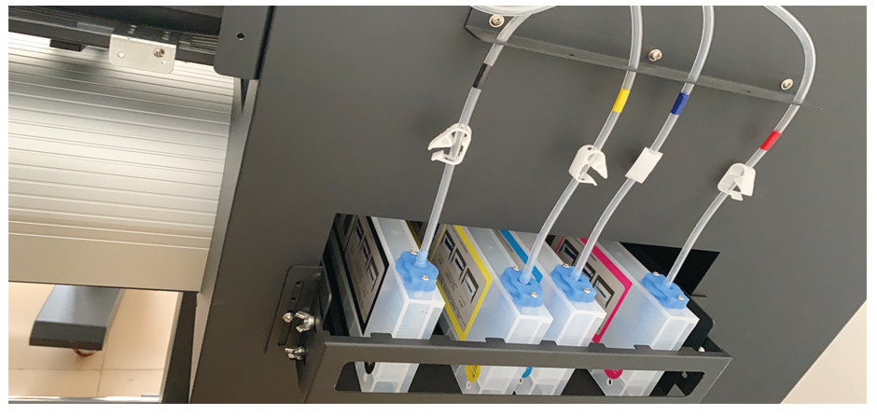

Print head Maintenance Station(Print Head cleaning station)

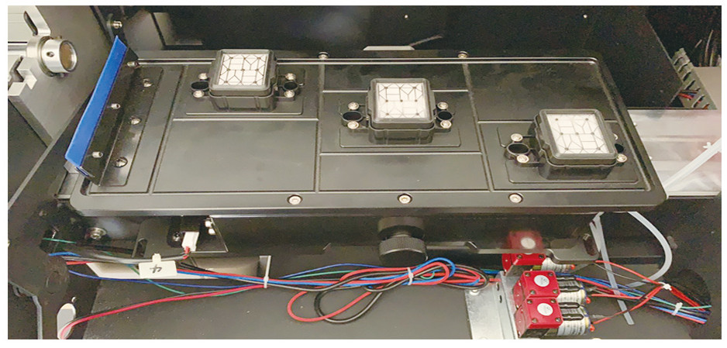

Media Pinch Roller

